

Elkor Meter integration with Site controller (Gridscape US Lab)

# Introduction

The WattsOn-Mark II Precision Energy Meter uses cutting-edge metering technology to provide unprecedented accuracy, resolution, and metering performance for any electrical installation. WattsOn monitors each phase individually and incorporates the functions of single-phase, split-phase, and three-phase meters.

* 1. Important Links

Product Link: <https://www.elkor.net/product/WattsOn-Mark_II>

Datasheets: <https://www.elkor.net/pdfs/WattsOn-Mark_II_Datasheet.pdf>

Manual Link: <https://www.elkor.net/pdfs/WattsOn-Mark_II_Manual_Complete.pdf>

<https://www.elkor.net/pdfs/W2-Display_Guide.pdf>

<http://www.elkor.net/pdfs/AN0802-WattsOn_Troubleshooting.pdf>

<https://www.elkor.net/pdfs/WattsOn-Installation_Considerations.pdf>

<https://www.elkor.net/pdfs/MRS_Series_CTs.pdf>

<http://www.elkor.net/pdfs/AN0806-WattsOn-Mark_II-Advanced_Configuration.pdf>

Product Support Link: <https://www.elkor.net/support.php>

* 1. Models In Our Lab

We have the below-mentioned meter and CTs models in our US_GS Lab.

Energy Meter (quantity 1): **W2-E4-mA-DL**

WattsOn-Mark II Power Meter, mA inputs, integrated ETport, Logging/Display module, Ethernet/WiFi, Logging/Display module

CTs (quantity 3): **MRS-125**

Miniature revenue-grade split-core current transformers.

* 1. Meter Specifications: 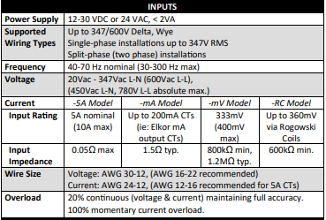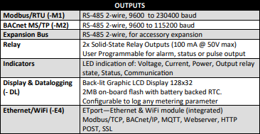

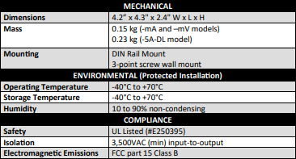

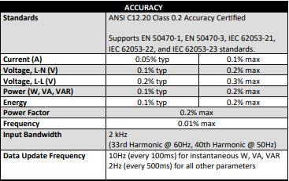



* 1. Measured Parameters (available via Modbus)
* Voltage [V] (A, B, C, Avg, AB, AC, BC, Avg)
* Current [A] (A, B, C, Avg) Active Power [W] (A, B, C, Total)
* Bi-directional Apparent Power [VA] (A, B, C, Total)
* Reactive Power [VAR] (A, B, C, Total)
* Bi-directional Power Factor (A, B, C, System)
* Bi-directional Active Quadrant (A, B, C, System)
* Voltage Phase Angle [°] (AB, AC, BC)
* Frequency [Hz]
* Import/Export/Net Real Energy [Wh] (A, B, C, Total)
* Import/Export/Net Apparent Energy [VAh] (A, B, C, Total)
* Q1/Q2/Q3/Q4 Reactive Energy [VARh] (A, B, C, Total)
* Total Demand Power (Sliding Window) [W]

**NOTE**: All parameters are accessible in integer and floating-point format.

* 1. Wiring Diagram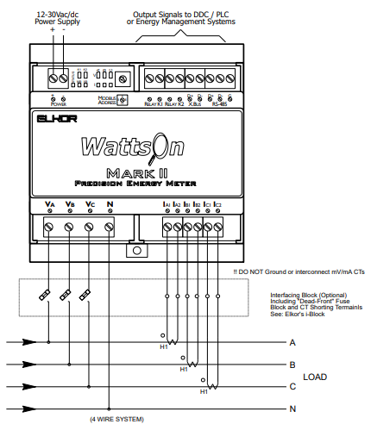

Typical four wire system: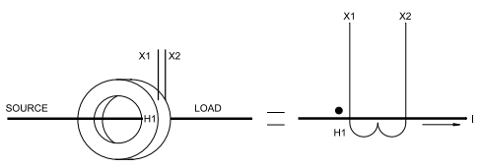

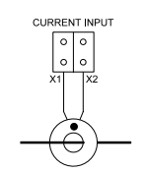

**NOTE**: CT Orientation (on the conductor), CT Polarity (into the meter), and CT phasing (relationship to voltage phase) MUST be observed for correct meter operation.

1. Testing Setup
   1. Lab Connection 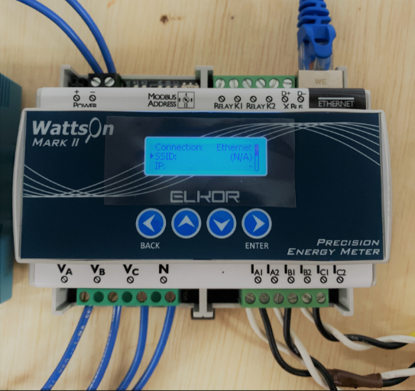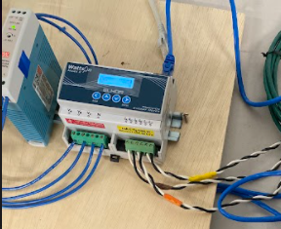
   2. Read parameter

The Elkor(E4 model) meter supports wifi networks.

* + 1. Accessing the web interface
* Open web browser (recommend: Mozilla Firefox or Google Chrome)
* Direct it to the device’s IP address.
* Web Page is shown below

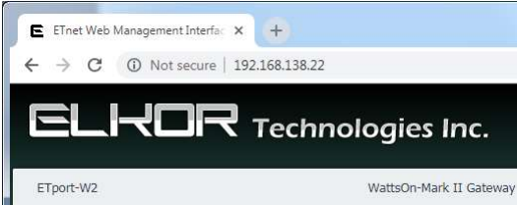

* + 1. Accessing IP address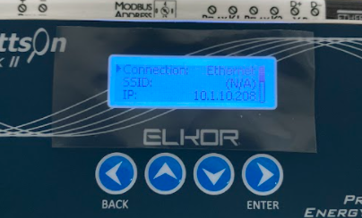
* Go on display
* Enter in configuration
* Enter connection configuration

Lab Elkor meter IP: 10.1.10.208 (may change)

Login ID: admin

Pass: admin

* + 1. Accessing parameter reading via the Modbus Poll 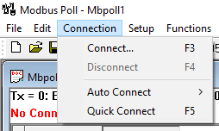
* Open Modbus Poll tool
* Open /click on the connection on the Menu bar
* Goto connect (short key F3) (see figure) →
* Open connection setup
* In connection, setup drop-down Connection manu
* Select Modbus TCP/IP
* Set Device IP address (at the left bottom)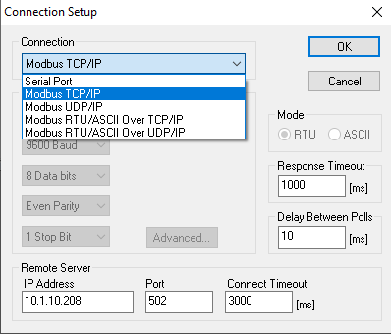
* Port 502 (default)
* Then click OK

Now your device is accessible through the Modbus poll tool.

For more information on the Modbus, poll refer: [Modbus Poll User manual](https://www.modbustools.com/mbpoll-user-manual.html#_exception_and_error_messages)

* + 1. Modbus Poll file for Elkor meter

Instantaneous data registers contain the real-time measurements from the input channels on the device, including current, voltage, power, power factor, and frequency.

For Modbus register map , refer [Wattson-Mark II Manual](https://www.elkor.net/pdfs/WattsOn-Mark_II_Manual_Complete.pdf)(page no 34, section 6 Modbus Protocol)

Modbus poll File:

* [Elkor Modbus map](https://drive.google.com/drive/folders/1sPtnkZqEUJC8KXlSpsOHOQjYwzbbl9QE?usp=sharing)
  + 1. Configuration and Status Registers
       1. Setting CT Ratios

If a 100A:5A CT is being used, write the value “100” to register 0x500(41281). Leave register 0x501(41282) at its default value of “5”.

In our case CT is **7500:1**, so write value “7500” to register 41281 and write 1 to register 41281. This register makes changes for all phase CTs.

For individual set CT ratio do change following register,

* Primary CT Ratio A 0x502(41283)
* Secondary CT Ratio A 0x503(41284)
* Primary CT Ratio B 0x504 (41285)
* Secondary CT Ratio B 0x505 (41286)
* Primary CT Ratio C 0x506 (41287)
* Secondary CT Ratio C 0x507 (41288)
  + - 1. Uptime

The uptime register reports the number of seconds that the device has been running. This counter is reset when the device is powered off, reset, or the bootloader is started. Writes to this register are permitted if desired to represent a date, time, or elapsed time counter.

* + - 1. Setting 32-bit Endianness

By default, the higher-order 16-bit word of a 32-bit register is the register with the lower Modbus address, and the lower order word is at the higher address. Most Modbus software and devices will interpret 32-bit registers this way. Writing a “1” to the 32-bit Little Endian register at address 0x51A (41307) configures the WattsOn to reverse the 16-bit word ordering so that the higher-order word is at the higher address, and the lower-order word is at the lower address. See the following table for an example.

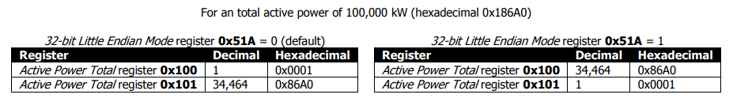

* + - 1. Resetting Accumulated Energy

To reset the resettable accumulated data registers to 0, write the hexadecimal value 0xA5A5 (decimal value 42405) into the Energy Reset register, 0x524(41327).

**Note**: this will not affect that data in the revenue accumulated data registers; they will continue to hold their former values despite any resets.

* + - 1. Frequency Measurement Channel

Frequency is measured using one of the three voltage channels. By default, the device will automatically select a voltage channel with an RMS voltage greater than 5V on which to perform the frequency measurement. If the voltage in this channel falls to below 5V, a new channel will be automatically selected. If no channel contains a voltage above this threshold, the frequency will read “0”. The channel currently being used is displayed in the Frequency Active Channel register, 0x533 (0, 1, and 2 represent channels A, B, and C, respectively).

The meter may instead be forced to use a specific voltage channel for frequency measurement. To do so, first disable automatic channel selection by writing “0” into the Auto Frequency Channel register, 0x532. Then, write a value into the Frequency Active Channel register corresponding to the desired channel to be used for frequency measurement, with “0” representing channel A (the first channel from the left), “1” representing channel B, and “2” representing channel C.

* + - 1. Scratch Pad Registers

There are 32 scratchpad registers available, starting at register 0x540 and ending at 0x55F. Any values can be written to these registers. Values written to these registers will be stored in non-volatile memory so that they are retained after the device has been powered off or rebooted. These can be used for room numbers, customer IDs, or any other purpose as desired. These registers are not used for any measurement purposes.

* 1. Test Result / Reading
     1. CT configuration

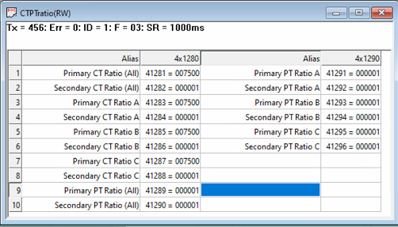

* + 1. Observation
* Reading of Modbus register and UI is same except frequency and L-L parameter
* In hexadecimal value, frequency and L-L parameters give correct results but not in signed integers.
* Floating-Point Instantaneous Data Registers, Resettable Floating-Point Accumulated Data Registers, and Revenue (Non-Resettable) Floating-Point Accumulated Data Registers do not show proper reading.
* UI shows only the L-N parameter, Import-Export Energy (all three) data, And for other parameters read from Modbus.
* We can’t configure the meter from the UI / HMI.
* There is 32 Scratch Pad Register available for storage purposes like we can store Customer ID, site ID, etc.
* For resetting the energy to zero write 0xA5A5 (42405) in the “Energy Reset (41317)” register.
* System frequency and L-L parameter gives correct value in hex and unsigned integers
* Apparent Power Modbus doesn’t sync with the web interface as well as the other values
  1. Conclusion
  2. Questions for Elkor support
* The web page of Elkor meter, How many and which parameter show?
* **Is it possible to get a different access point to the Advanced configurations document? The one provided does not work** (related to CT polarity)
  + <http://www.elkor.net/pdfs/AN0806-WattsOn-Mark_II-Advanced_Configuration.pdf>
* **Is there any configuration required to set up Modbus registers and if so,** how is it configured?
* Some Modbus register values do not match to the value which shows on the display and UI page, so what is the reason behind that? Is that a bug ??
  + Can you please elaborate and give more details (screenshot if possible)? If there are discrepancies in the webpage interface, we need to investigate. Regarding “setting up the Modbus registers”, we do have a feature to create custom register maps (ie: move the registers around), however, it is seldom used. I’m not sure if you are referring to this, but the register map in the documentation manual should all be correct.
* How come in the modbus poll, the hex value matches the UI interface but the signed integer value does not match. The signed integer value is also negative? Is this a bug? This has been consistent for the frequency and the line-to -line voltages
* **Can we access the meter in the “modbus commander tool” via IP instead of the ethernet cable (modbus connector port)? If yes, then** how to do it?
  + Do you mean “instead of the RS-485 cable”? Yes, absolutely. You must know the IP address of the meter in question. This can be configured through the “Setup > Ethernet Settings” menu. The default TCP/IP port is 502.
* How to configure the CT and other settings from the Web page of Elkor meter?
* How many devices can we connect through Modbus TCP/IP? We want to set up about 4-5 metering points using 4-5 different Elkor meters and are curious how many devices we can configure onto one controller, where the controller acts as the master and the meters as slaves.
  + The answer to this question is a bit complex because the unit has multiple connection handlers that can each handle several protocols (Modbus, BACnet, web server, HTTP posting), however, presuming that you are only using the Modbus TCP protocol, it is safe to assume at least 8 simultaneous connections. Also note that the frequency of polling will have an effect on the response capabilities of the meter, as it has to queue each request in sequence.
* As you mentioned in your previous email, "the web interface does not currently allow for configuration changes to the meter, it can easily be done using our free Modbus Commander Software". - How can we remotely connect the Modbus Commander Software and the meter to change voltage and current parameters?
  + What do you mean by “remotely connected”? If you have ethernet access (ie: on the same LAN) to the meter, then you can connect to via Modbus Commander (as above). It is technically possible to do port forwarding (port 502) across a firewall to access the Modbus TCP/IP connection and thereby use Modbus Commander. However, we STRONGLY discourage this method of connection as it could lead to security concerns. It is technically possible to lock down any and all writes to the meter via a 32-bit password, although this is not super secure.  
      
    It is technically possible to do arbitrary Modbus operations using the API (via webserver / port 80), however, again it is not advisable to have this accessible outside of a secure LAN due to security concerns. In the majority of applications, the meter configuration is performed at the time of install/commissioning (usually via the on-board display), and it never changes. I would be interested in your use case for remotely changing the meter configuration.  
      
    For remote access, we strongly encourage the use of a VPN or secure tunnel.
* Please refer to the picture attached (Image_1), if we set up the Elkor meters in that format then how many Meters we can connect, and what would be the effect of this setup in terms of accuracy of the meter? We believe we can connect up to 254 meters but can you confirm?

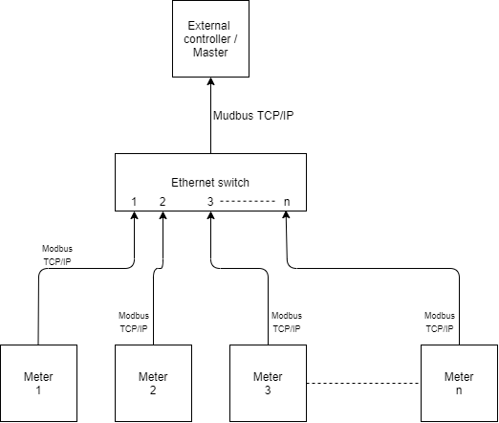

* + In an ethernet network, there is technically NO limit to the number of meters you could communicate with. Unlike Modbus/RTU, the E4 meters are uniquely addressed via their IP address. The IP addressing limitations depend on your network configuration. Note that the E4 meters all have a Modbus ID (address) of “1” since their unique identifier is their IP address.
* While following the advance configuration document we found the information needed to change CT directions remotely. But is there any way that we can configure Meter's network voltage wiring configuration remotely? For example, can we remotely change the 3P+N network connection to 2P+N or any other desired network connections as per requirement?
  + There are no required changes necessary between a 3P+N and 2P+N setup. In a 2P+N setup, some of the registers (ie: “phase C”, average, etc) are just meaningless and can be ignored by your system. The calculation of total power/energy does not change. The meter will just measure the phases that you connect to it. There is no reboot, reconfiguration, or reset required.
* Also to access advanced configuration registers we followed the steps mentioned on the page-5 of the document that you shared with us and found that after successfully installing the plugins we no longer see the " Device" tab when we install an additional plugin from this link <http://www.elkor.net/bin/ModbusCommanderElkorDeviceAdvancedPlugin.dll>
  + This is a quirk of Windows 10. It doesn’t easily allow installation of DLLs after a program has been installed. Instead, please use the dedicated installer that has the plugin already included: <http://elkor.net/bin/MC_19130_ADV_CAL.exe>
* Referencing the attached photo Elkor_3, under the ethernet setting we are not able to scroll or view the buttons needed to fix anything. Do you have any advice on the matter?

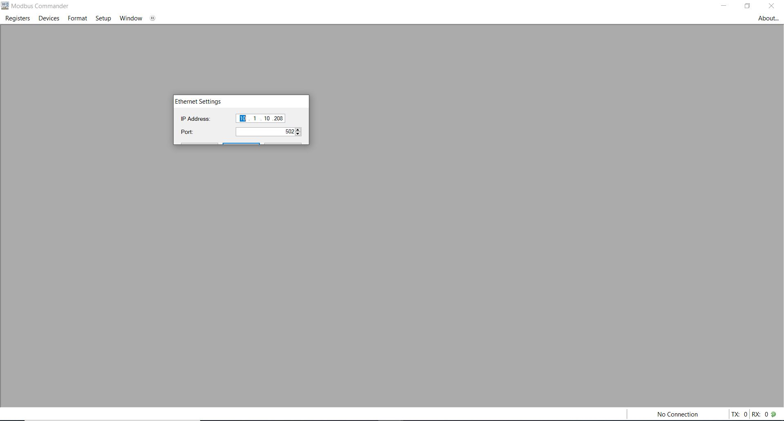

* + This is a problem with Windows 10 and high DPI settings. We need to look into this, but the buttons are simply “Apply”, “OK” and “Cancel” (see screenshot). If you make your settings and press enter, they should stick. I will discuss it again with our developers.

